**Commonly Used Patterns in Technical Analysis**

**Haocong Wang**

**mw814@scarletmail.rutgers.edu**

16:332:568 Software Engineering of Web Applications

Feb. 9, 2020

**1. Introduction**

Technical analysis is one of the most commonly used methods for investors to analyze the risk and make investment decisions. Unlike fundamental analysis, which takes the financial statements into consideration, technical analysis assumes that the security’s price already represents all the information that need to be considered and thus focuses on the numerical data and figures.

Technical analysts harbor the idea that all the information to analyze the stock price is included in the stock chart. Patterns and indicators are used to help investors understand what is happening to a certain stock. In this essay, I will introduce trend lines and channels, support and resistance, several patterns and indicators.

**2. Trend Lines and Channels**

Technical analysis is built on the assumption that prices trend and thus the use of trend line is of importance. Trend line is easy to define and understand: it is a straight line that connects two or more price points and is the general direction in which a security or market is headed.

Basically, there are three main types of trend lines: uptrend, downtrend and sideways/horizontal trends. The sideways trends are used when there is no obvious up or down, which means the price moves quite slowly that it is hard to tell the direction of movement.

Unlike the definition, to draw a trend line, however, is not that easy due to the complexity of prices’ movement. To solve that problem, we define the general direction of peaks and troughs as trends. We need at least two peaks and troughs for uptrend or downtrend, respectively.

Figure 1 – Examples of a uptrend (purple) and a downtrend (red)

Figure 1 is the stock price of Google from 11/9/2018 to 9/25/2019. I drew an uptrend and a downtrend. It turns out that the volumes went down before May 2019 because the stock price of Google increased steadily. However, between May and June, the volumes went up suddenly because the stock price dropped, which means the holder of stocks wanted to sell their shares to stop their loss.

Figure 2 – Example of Channel

Figure 2 shows a price channel of Google stock. A channel appears when we have two parallel trendlines. These two trendlines act as strong areas of support and resistance with the price bouncing around between them. In figure 2, we can see that the volumes do not change much.

**3. Support and Resistance**

The concepts of support and resistance are undoubtedly two of the most highly discussed attributes of technical analysis. Support is a price level where a downtrend can be expected to pause due to a concentration of demand. As the price of assets or securities drops, demand for the shares increase, thus forming the support line.1﻿ Meanwhile, resistance zones arise due to a sell-off when prices increase.

Once an area or "zone" of support or resistance has been identified, it provides valuable potential trade entry or exit points. This is because, as a price reaches a point of support or resistance, it will do one of two things—bounce back away from the support or resistance level or violate the price level and continue in its direction—until it hits the next support or resistance level.

**4. Patterns**

In technical analysis, transitions between rising and falling trends are often signaled by price patterns. By definition, a price pattern is a recognizable configuration of price movement that is identified using a series of trendlines and/or curves. When a price pattern signals a change in trend direction, it is known as a reversal pattern; a continuation pattern occurs when the trend continues in its existing direction following a brief pause. Technical analysts have long used price patterns to examine current movements and forecast future market movements.

**4.1 Head and Shoulders**

Head and shoulders patterns can appear at market tops or bottoms as a series of three pushes: an initial peak or trough, followed by a second and larger one and then a third push that mimics the first. An uptrend that is interrupted by a head and shoulders top pattern may experience a trend reversal, resulting in a downtrend. Conversely, a downtrend that results in a head and shoulders bottom (or an inverse head and shoulders) will likely experience a trend reversal to the upside. Horizontal or slightly sloped trendlines can be drawn connecting the peaks and troughs that appear between the head and shoulders, as shown in the figure below. Volume may decline as the pattern develops and spring back once price breaks above (in the case of a head and shoulders bottom) or below (in the case of a head and shoulders top) the trendline.

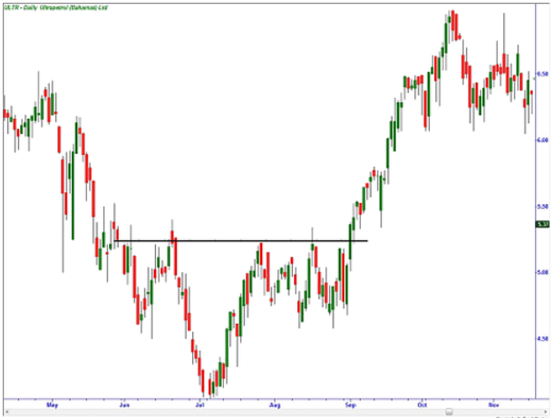

Figure 3 – Head and Figure

**4.2 Cup and Handles**

The cup and handle is a bullish continuation pattern where an upward trend has paused, but will continue when the pattern is confirmed. The "cup" portion of the pattern should be a "U" shape that resembles the rounding of a bowl rather than a "V" shape with equal highs on both sides of the cup. The "handle" forms on the right side of the cup in the form of a short pullback that resembles a flag or pennant chart pattern. Once the handle is complete, the stock may breakout to new highs and resume its trend higher.

Figure 4 – Cup and Handles

**4.3 Triangles**

Triangles are among the most popular chart patterns used in technical analysis since they occur frequently compared to other patterns. The three most common types of triangles are symmetrical triangles, ascending triangles, and descending triangles. These chart patterns can last anywhere from a couple weeks to several months. Symmetrical triangles occur when two trend lines converge toward each other and signal only that a breakout is likely to occur—not the direction. Ascending triangles are characterized by a flat upper trend line and a rising lower trend line and suggest a breakout higher is likely, while descending triangles have a flat lower trend line and a descending upper trend line that suggests a breakdown is likely to occur. The magnitude of the breakouts or breakdowns is typically the same as the height of the left vertical side of the triangle, as shown in the figure below.

Figure 5 - Triangles

**5. Conclusion**

As I mentioned in the beginning of this essay, technical analysts believe that all the information that the investors need to know is covered in the stock prices. After searching for materials of technical analysis, I came to believe that this theory does make sense. According to the chaos theory, seemingly random processes may, in fact, have been generated by a deterministic function that is not random. These data, figures and patterns, which can be used as training set for machine learning algorithm, provide vital support for analyzing prices.

**Reference**

[1]: Technical analysis, https://en.wikipedia.org/wiki/Technical_analysis

[2]: Fundamental analysis, https://en.wikipedia.org/wiki/Fundamental_analysis

[3]: Trend lines, https://school.stockcharts.com/doku.php?id=chart_analysis:trend_lines

[4]: Yahoo Finance, GOOGLE stock, https://finance.yahoo.com/chart/GOOG

[5]: Support and Resistance Basics,

https://www.investopedia.com/trading/support-and-resistance-basics/

[6]: Introduction to Technical Analysis Price Patterns,

https://www.investopedia.com/articles/technical/112601.asp

[8]: Software Engineering, Ivan Marsic, Page 35-36